JANTA VIDYA MANDIR GANPATRAI RASIWASIA COLLEGE, CHARKHI DADRI
Faculty Profile

Department-Chemistry

Name of Faculty |  | 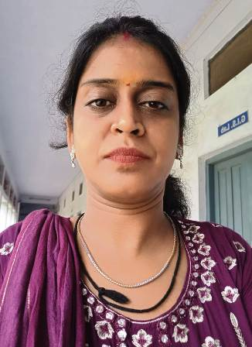  Ms. Hemlata
Department |  | Geography
Designation |  | Assistant Professor
Experience |  | 11 Year 5 Month
Contact No |  | 7015531298
Email Id |  | Hemlata.ban@gmail.com
Date of Joining |  | 02-09-2013
Educational Qualification
 | Name of Program |  | Year of  Passing | University
PG | M.A |  | 2010 | PU, Chandigarh
Ph.D. | Pursing |  |  | BMU, Rohtak
Net | Geography |  | 2012 | UGC (NET)
Other
Research Supervision/Guidance  ` |  |  | NIL
Research Publications |  |  | 02 Research Paper in UGC Care Listed Journals  03 Research Paper in International Peer reviewed Journals
Books Published |  |  | NIL
Book Chapters |  |  | 01
Papers Presented in Conferences/ Seminar |  |  | International:08 National:17
Participated in Conferences/ Seminar |  |  | International:08 National: 02
No. of Workshops/FDP/Training Programme Attended |  |  | Workshop 2  FDP 4  TRAINNING PROGRAMME 3
Major/Minor Research Project |  |  | Nil
Invited Lectures |  |  | 01
Awards/Honours |  |  | - Best Youth Red Cross Counsellor (Female by Red Cross Society)
Membership of Any  Professional/ Statutory Body |  |  | - Life Membership of National Association of Geographer of India  - Life Membership of Indian Red Cross Society  - Life Membership of Rashtriya Hindi Patrika  - Okkf’kZd lnL;rk iaaptU; if=dk
Any Other Achievement |  |  | - Participated in District Level 5 Day YRC Counsellor (Two Times).  - Organized 5 Day District Level YRC Camp (Three Times) .  - Participated in 21 Day Webinar Series Conducted by IIRS, ISRO.  - Participated in u”kk eqfDr tu tkxj.k vfHk;ku by (District Red Cross Society).  - Participated in State Level Quiz on RRC/AIDS/HIPA Panchkula.  - One Day Orientation Course by YRC.  - Certificate of Appreciation in Recognition for a Record of Outstanding Accomplishment (District Level Quiz)

